CS7CS4 Research Assignment 2  
TEAM ID: 25 TASK ID: 104 - DATA AMOUNT  
Bhaskar Rao  
raob@tcd.ie  
18300829  
 Bhavesh Mayekar  
mayekarb@tcd.ie  
18301407  
 Hamid Hassani  
hassanih@tcd.ie  
15338952  
  
CONTRIBUTION  
All the team members have contributed equally during the project. The team met every second day at the Lloyd building to brainstorm, plan project and discuss the results and alsthe team had several skype meetings. Team finalized the 3 data sets to be used for the research question (available on the Github repo). Team then distributed data sets between themselves (1 for each member) and started their analysis. Individual work contribution has been detailed below:  
  
Bhaskar Rao: He worked on the public “Bike Sharing Dataset” from UCI machine learning repository. The dependent variable (continuous) was the count of the number of bicycles rented per day and dependent variables had information about the weather conditions and specifics of the day (holiday, weekend or weekday). He did EDA, data cleaning, feature engineering on the data set before implementing machine learning models to predict the count of bikes rented. He also performed cross-validation and employed ensemble techniques to improve the models. He the analyzed the effect of training data size on the accuracy of the model. He discussed his results and findings with the team and asked for help whenever required.  
  
Bhavesh Mayekar: He worked on the publicly available “Census Income Data Set” from UCI machine learning repository. He performed various data cleaning and feature engineering operation on the dataset and implemented various machine learning models. The aim was to predict the whether an individual has a salary above 50k based on various input parameters. He tested various models with varying sizes of training datasets and analyzed the accuracy. Later the results and findings were discussed with the team. This data set was not added in the final report, as there was a limitation of 1500 words. Also, he helped the team in data preprocessing and feature engineering of other two datasets and reviewed codes.

Link of income dataset: <https://github.com/bhaskarrao511/CS7CS4--task-104--team-25/tree/master/Income>

Hamid Hassani: He worked on the publicly available “Bank Marketing Data set” from UCI machine learning repository. He did detailed EDAs to visualized and understand the data find out the relation between input features and target variable. Also, he shared insights with other teammates. He implemented multiple classification models to predict if a customer will subscribe a term deposit based on marketing campaigns ran by the bank. He used this data set to find out the effect of training data amount on the accuracy of models. He also presented his results and incorporated team’s feedback to further improve his analysis.  
  
Apart from the individual analysis, team was also reviewed each other’s code and methodology. Team also collaborated to complete the research paper. Each individual prepared his own points for the paper and sat together to discuss and consolidate the key points using which the paper was finalized.

(Should be updated at the end!)

WORK COUNT   
Word count excluding cover sheet, title, author names, tables and figures, references, acknowledgement, and appendix is 977  
  
URL TO SOURCE CODE REPOSITORY  
https://github.com/bhaskarrao511/CS7CS4--task-104--team-25/tree/master/sourceCode   
  
URL TO SOURCE CODE REPOSITORY ACTIVITY  
https://github.com/bhaskarrao511/CS7CS4--task-104--team-25/graphs/contributors   
  
COMMIT ACTIVITY OF TEAM MEMBERS  
   
  
  
  
We would like to thank Prof. Joeran Beel and Prof. Douglas Leith for their teachings without which this research would have been impossible  
 Effects of varying training data amount on Machine Learning algorithm

Bhaskar Rao  
Trinity College Dublin raob@tcd.ie Bhavesh Mayekar  
Trinity College Dublin  
mayekarb@tcd.ie Hamid Hassani  
Trinity College Dublin  
hassanih@tcd.ie  
  
  
**1 ABSTRACT**  
Machine learning (ML) enables computers to analyze the data and learn without any explicit programming. This task requires data and acquiring good data for training the model is one the most expensive and difficult parts. The accuracy of the model depends upon the type, quality and quantity of it. This report studies the amount of data sufficient to train models by algorithms on two multivariate datasets. The result shows that increasing the size of training data will increase the overall accuracy but for some algorithms no significant improvement was achieved.  
  
Keywords – Machine Learning, Training Data, Accuracy, Regression Analysis, Classification Analysis

**2 INTRODUCTIONS**  
Machine Learning is a process by which computer can make prediction through analyzing the input data and it is either curve fitting or classification tasks. [1] In last few years, the use of machine learning has been increased tremendously due to improvement in computational power. A report published by McKinsey Global Institute claims that ML will revolutionize the future innovation [2].  
 In ML, data plays an important role and in order to train the algorithm, the data is divided into training and testing datasets. Therefore, the first question that arise is that how much data is required to train the model effectively. As per author’s knowledge, there is no definite answer to this, but in most scenario, it depends on various factors like complexity of the algorithm, input features, correlation between data etc.

**3 RELATED WORK**  
In [3], it was proposed that training size should be defined by specifying confidence interval widths for classification algorithm in bio spectroscopy field. As mentioned in [4], increasing the training dataset will overfit the model. It was found in [5] that how the performance of models vary with the training dataset size in biomedical applications. The investigation in [6] describe about how much training data is required to have an accurate model in medical image deep learning systems.

**4 METHODOLOGY**  
In this research, following steps were followed: identifying relevant datasets and their target features, data pre-processing, breaking the dataset into test and train, splitting training dataset into subsets of different length, build models upon these subsets, evaluate these models with the test data and compare the accuracy vs train data size.

**4.1 Data Sets**  
Two multivariate datasets from the UCI machine learning library were used for the research, “Bike Sharing” and “Bank Marketing” datasets. Former dataset has 17,379 observations and 16 features recorded for two years at day-hour level. The target variable is the number of bikes rented and features are environmental conditions at the hour.

The later dataset is a bank customer level data which has more than 40K instances and 10 features. Target variable is if the contacted customer subscribed to the bank term deposit or not and the features are bank client data and some information related to the last contact of current customer.

**4.2 Data Pre-processing**  
In both datasets, null values were treated, and exploratory data analysis (EDA) was performed to understand the datasets. Label encoding was applied on categorical variables.

**4.2.1 Pre-processing for “Bike Sharing” dataset**

**It is better to do not use we. Instead use passive sentences.**

Correlation analysis was performed to understand the relationship between the continuous(?) features and the dependent variable. From the heat plot in Fig. 1, we found no correlation between ‘windspeed’ and ‘cnt’ target variables, therefore it could be dropped. We saw a high correlation between ‘casual’ and ‘registered’ features (‘registered’ being the subset of ‘cnt’, won't be used), ‘casual’ will be dropped, as well. New features like Sunday flag (day is Sunday or not) and and day period (‘noon’, ‘evening’ etc.) were created to extract more useful information from data. Categorical variables like ‘season’ and ‘weather’ were label encoded.

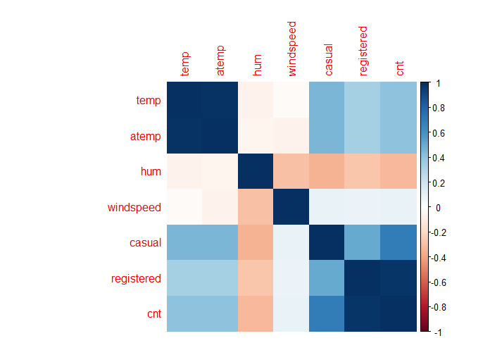  
Figure 1: Correlation analysis for bike-sharing dataset

**4.2.2 Pre-processing for “Bank Marketing” dataset**

In bank marketing dataset, most of the features were categorical, so they were encoded and transformed to quantitative data. Then, the outliers were detected with respect to quartile range and filled with closest values in range. Also, there was no any missing data in this dataset. In order to do feature selection in this dataset, some features will be visualized and analyzed in this section and reminded features in Appendix A.

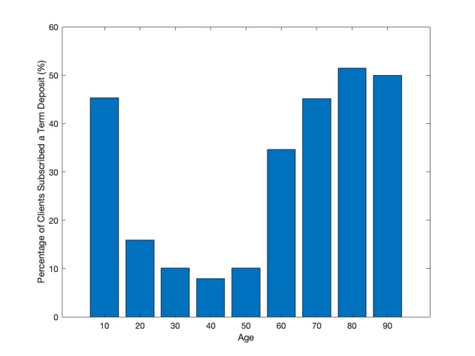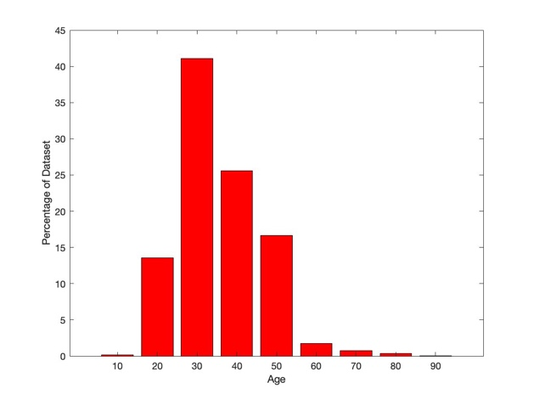

Figure 2: Analyze “Age” Feature

In Fig. 2, it has been shown that older people are more probable to subscribe a term deposit. However, the large portion of dataset contains young people. Hence, it would be better to change the campaign with more promotions for young people.

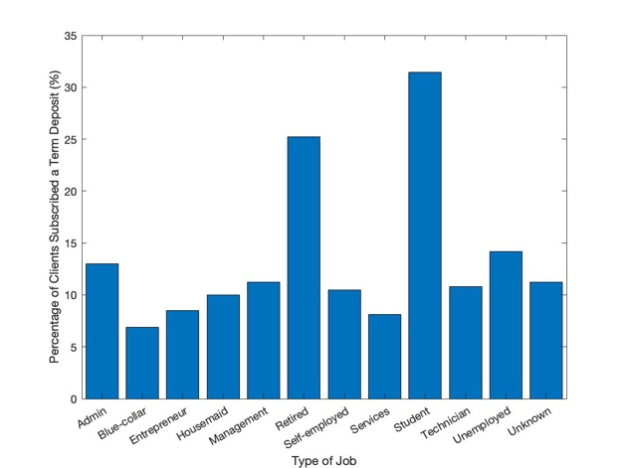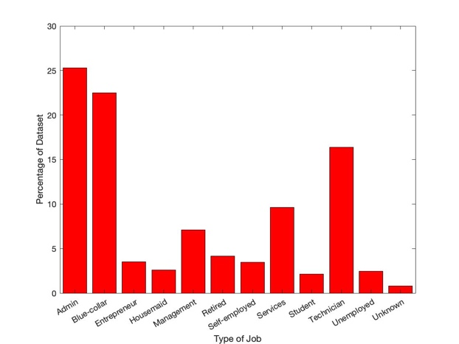

Figure 3: Analyze “Job” Feature

In Fig. 3, it has been shown that retired and students are more interested in subscribing a term deposit but they are less than 10% of whole dataset.

After doing feature selection, house and personal loans features were removed due to low correlation with target variables. Then, the continues “age” values were discretized to a multiple of 10 to improve the accuracy. Then, features were rescaled with min-max normalization method before building the model.

**4.3 Train data splitting**

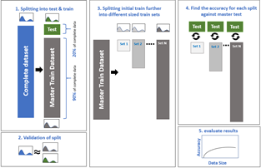  
Figure 4: Data splitting approach

To analyze the impact of data amount on the performance of ML algorithms, each dataset was split into validation and train parts in ratio of 20:80 as shown in Fig. 4. Then, some separate training datasets were further generated excluded from the initial train set. The difference between size of consecutive training sub-sets was (or were) constant, i.e. 10% of initial train data size. Furthermore, distributions of all validation and train datasets were compared with that of the complete dataset to verify sample selection.

**4.4 Model Building**  
All the models were implemented on the individual training sub-sets generated from the initial train dataset.

**4.4.1 “Bike sharing” dataset**

As dependent variables in the “Bike Sharing” dataset is continuous, linear regression (using R “Stats” package), ridge regression (using R “glmnet” package), support vector regression (“e1071” package) and random forest algorithms (“randomForest” package) were implemented and compared (I am not sure mentioning about the R packages is necessary just to save some words.). The weighted ensemble of all the algorithms was also calculated to understand the effects of ensembling on data amount. Hyperparameters were tuned based on cross-validation. The optimum value of (for) number of trees in Randomforest algorithm, penalty parameter (λ) in ridge regression and ensemble model weights were determined based on least error method. The hyperparameter used can be found in Table 1. (See appendix for detailed results.)

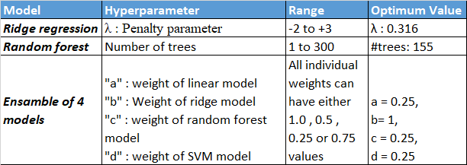

Table 1: Hyperparameters tuning for Bike Sharing data models.

**4.4.2 “Bank Marketing” dataset**

In “Bank Marketing” dataset, the target variable is binary, and the problem is a binary classification. Fig. 5 shows the distribution of the target variable in this dataset. It is obvious that it is an unbalanced dataset due to comparatively a smaller number of clients have subscribed a term deposit. Therefore, it is necessary to apply some metrics which are appropriate to this dataset such as F1 accuracy.

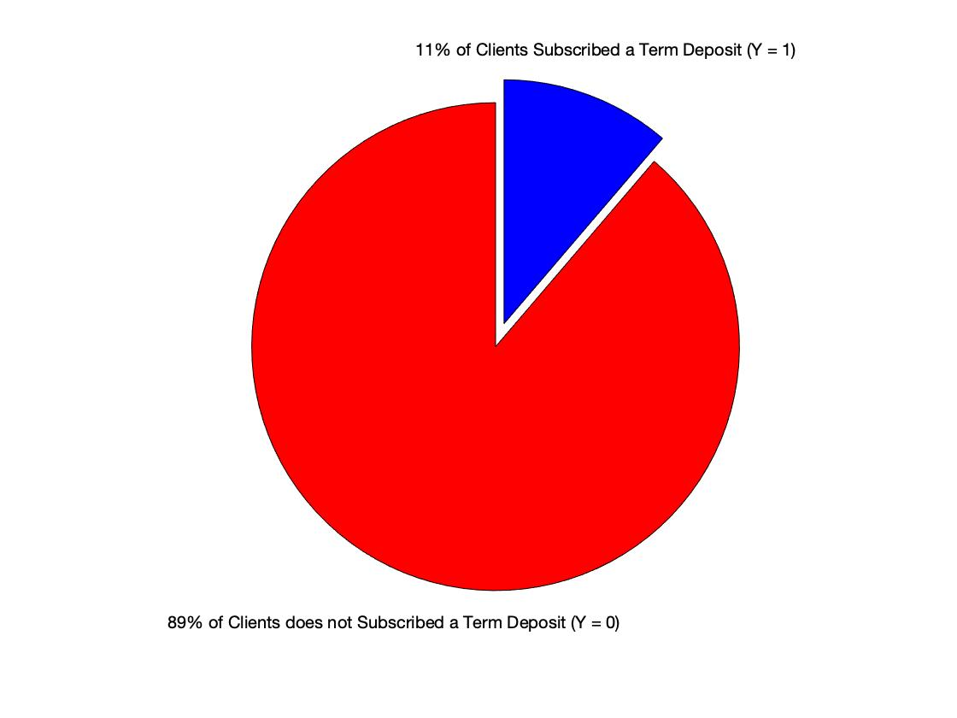

Figure 5: Distribution of Target Variable Y

In order to find a proper model, logistic regression, K nearest neighbor (KNN), decision tree, random forest and Gaussian Naive Bayes (GNB) algorithms were implemented in Python using scikit-learn library [10].

**5 RESULTS**

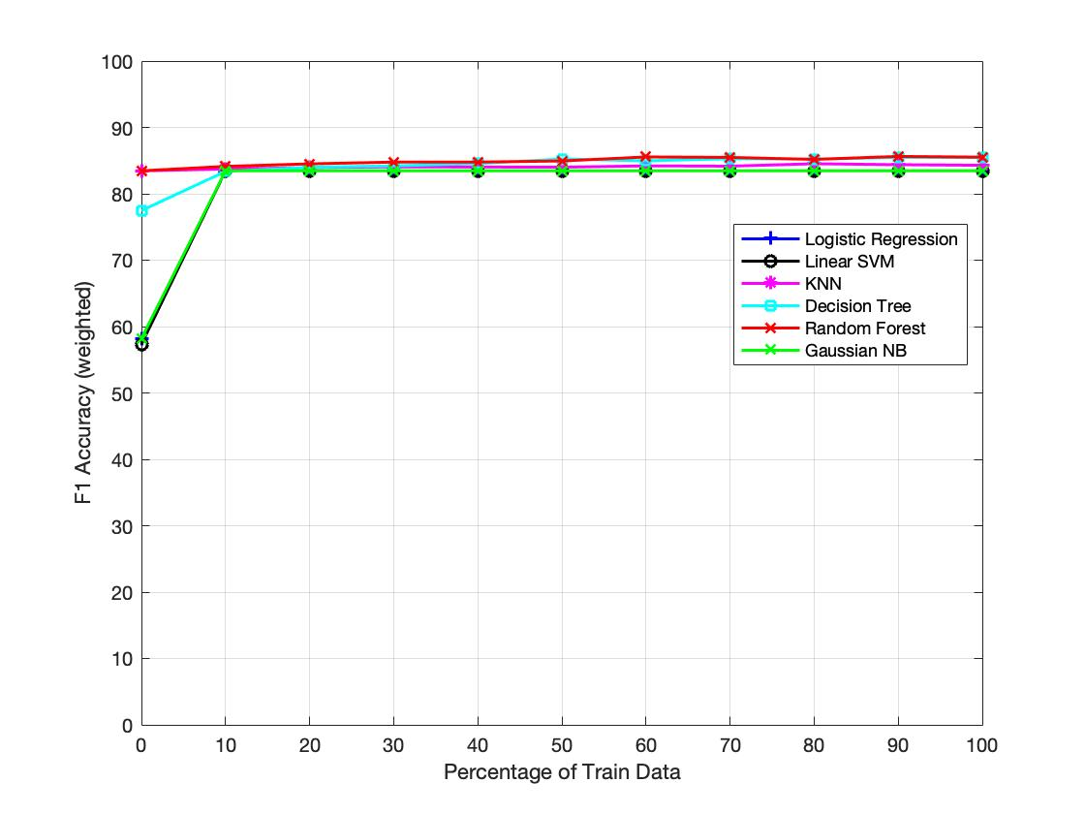  
 Figure 6: Accuracy vs. Train Data Size for the Bank Marketing Dataset

Fig. 6 shows the impact of varying training dataset size is related to selected classifier algorithm, in Bank Marketing dataset. In this figure, the first point on x-axis is 0.01% (>200 instances) and F1 accuracy calculated using bootstrapping with 20 times resampling. As shown in Fig. 6, logistic regression, linear SVM and Gaussian NB show a lower accuracy because of the underfitting phenomenon. However, KNN and Random Forest have higher performance. Then after increasing the size of dataset beyond 10%, there is no significant enhancement in the performance of the models are visible. It can be seen that more complex models like Decision Tree and Random Forest reach higher accuracy compared to the simple models like Logistic Regression, GNB and KNN. In addition, it is clear that after increasing the size of training dataset to 10%, all the applied methods in this setup behave in a same fashion without any obvious change in the overall accuracy. Therefore, the size of training data changes the accuracy in some algorithm, but complex ones are more robust to decrease the number of input instances for training.  
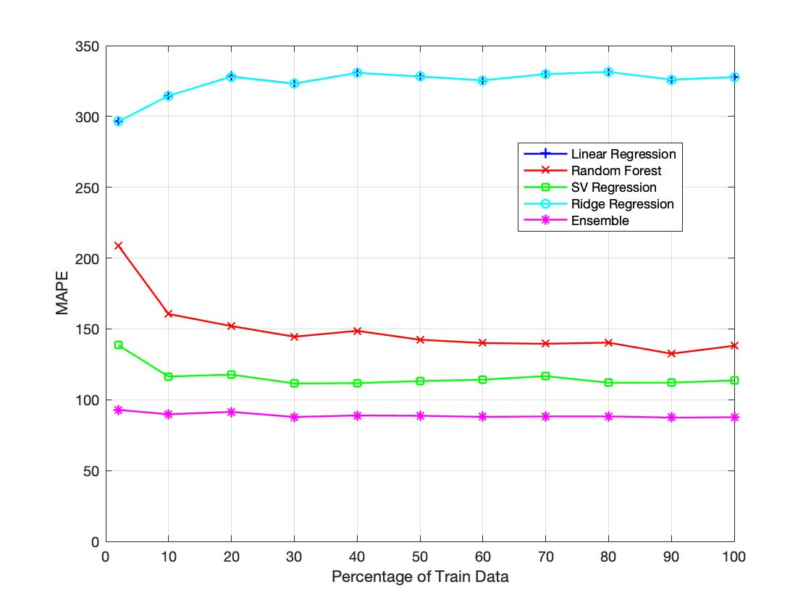

Figure 7: MAPE vs. Train Data Size for the Bike Sharing Dataset

For the Bike Sharing dataset in Fig. 7, all (linear regression and ridge regression have similar trends) the algorithms behave differently when size of training dataset is increased. For linear regression model, mean absolute percentage error (MAPE) increased till 20% of train data size and then eventually becoming nearly constant after 40% or 20%. Ridge regression performs very similar to linear regression (almost perfect overlap in graph X), this is because of low multicollinearity in our data (reduced via correlation analysis). In case of support vector regression model, error decreases till the train size is 30% of overall training data but beyond this, error becomes almost constant. For more complex model like random forest, model’s error decrease constantly when size of training data increase. The results of these models were ensembled to get the weighted average prediction, this ensemble performed the best and have lowest MAPE of ~ 88%. (write this sentence again ☺)The error remained constant with increase in data size, this is due to the fact that both bias and variance are reduced by the weighted average ensembling of different models. (add an adverb> Therefore, to sum up,) The size of dataset has a significant impact of machine learning models up to a certain level. Complex models will have better accuracy compared to linear/simple models and ensembling will give the best results consistently.   
  
   
**6 LIMITATIONS AND OUTLOOK**  
To further investigate about the impact of training dataset size on accuracy, the current models can be improved by using optimized feature engineering. Feature selection and missing value imputation have an impact on the accuracy. Next plan would be to implement algorithms on Census Income Data Set and a few more datasets related to different applications.

For bank marketing, we can do feature engineering and combine some features and generate promising new ones. In addition, we can use some wrapper methods to reduce the complexity of model.  
**ACKNOWLEDGMENTS**  
This analysis was conducted as part of the 2018/19 Machine Learning module CS7CS4/CS4404 at Trinity College Dublin).

**REFERENCES**[1] P. Domingos. 2012. A few useful things to know about machine learning. Communications of ACM, vol. 55, no. 10, 78–87  
[2] J. Manyika, M. Chui, B. Brown, J. Bughin, R. Dobbs, C. Roxburgh, and A. Byers. 2011. Big data: The next frontier for innovation, competition, and productivity. Technical report. McKinsey Global Institute.  
[3] C. Beleites, U. Neugebauer, T. Bocklitz, C. Krafft, J. Popp. 2013. Sample size planning for classification models. Analytica Chimica Acta, Volume 760, 25-33.  
[4] Friedman, J., Hastie, T., and Tibshirani, R. 2001. The elements of statistical learning, (2nd. Ed.). Springer Series in Statistics, New York.  
[5] Hajian-Tilaki, K. 2014. Sample size estimation in diagnostic test studies of biomedical informatics. Journal of biomedical informatics, Vol 48, 193–204.  
[6] Cho, J., Lee, K., Shin, E., Choy, G., and Do, S. 2015. How much data is needed to train a medical image deep learning system to achieve necessary high accuracy? arXiv: 1511.06348 . https://arxiv.org/abs/1511.06348  
[7] Sun, C., Shrivastava, A., Singh, S., and Gupta, A. 2017. Revisiting unreasonable effectiveness of data in deep learning era. arXiv:1707.02968. Retrieved from https://arxiv.org/abs/1707.02968  
  
[8] Fanaee-T, Hadi, and Gama, Joao, 'Event labeling combining ensemble detectors and background knowledge', Progress in Artificial Intelligence (2013): pp. 1-15, Springer Berlin Heidelberg.  
[9] [Moro et al., 2014] S. Moro, P. Cortez and P. Rita. A Data-Driven Approach to Predict the Success of Bank Telemarketing. Decision Support Systems, Elsevier, 62:22-31, June 2014.

[10] [Scikit-learn: Machine Learning in Python](http://jmlr.csail.mit.edu/papers/v12/pedregosa11a.html), Pedregosa *et al.*, JMLR 12, pp. 2825-2830, 2011.

**APPENDIX A**

In this section, the other input features of Bank Marketing dataset will be discussed in more detail as follows:

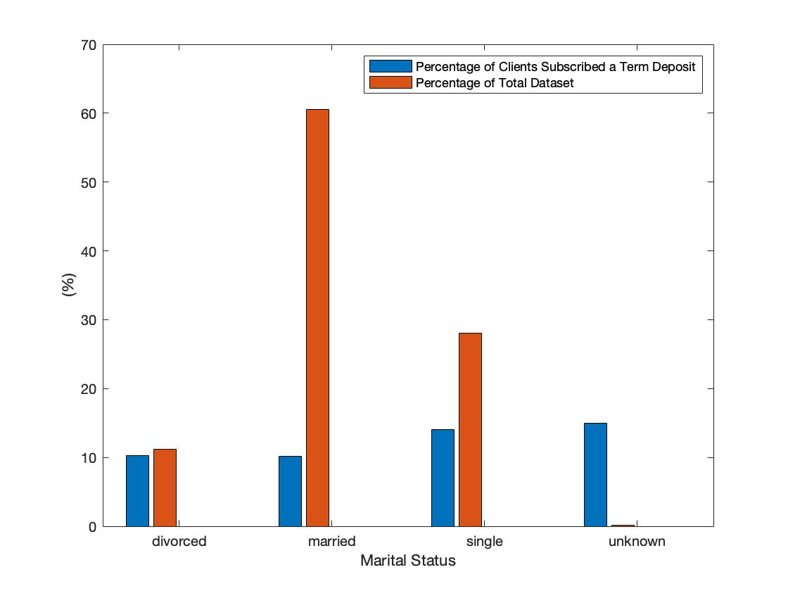

Figure 8: Analyze “Marital” Feature

Fig. 8 shows the relation between marital statues and subscribing to a term deposit. It could be seen that single clients are a bit more probable to subscribe a term deposit.

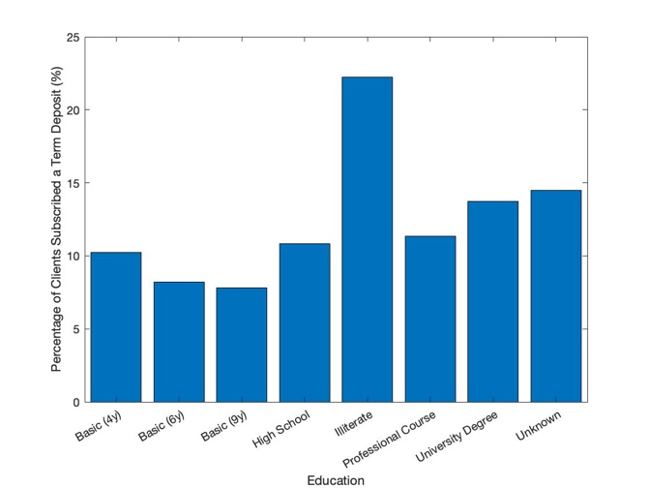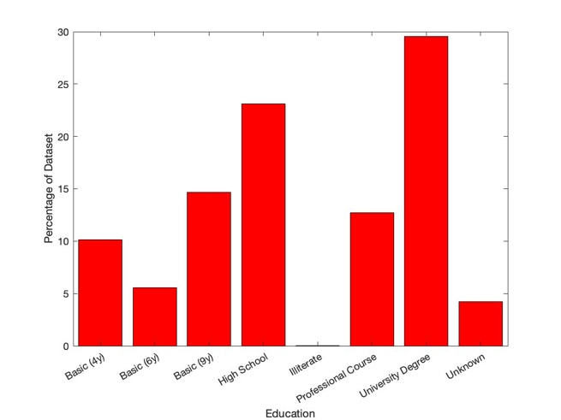

Figure 9: Analyze “Education” Feature

In Fig. 9, the impact of education level in target variable has been shown. Here, the illiterate people are more interested in subscribing a term deposit, but they are less than 1% of dataset. In addition, the probability of subscribing for other education levels are roughly close to each other. So, we should not expect effective information from this feature.

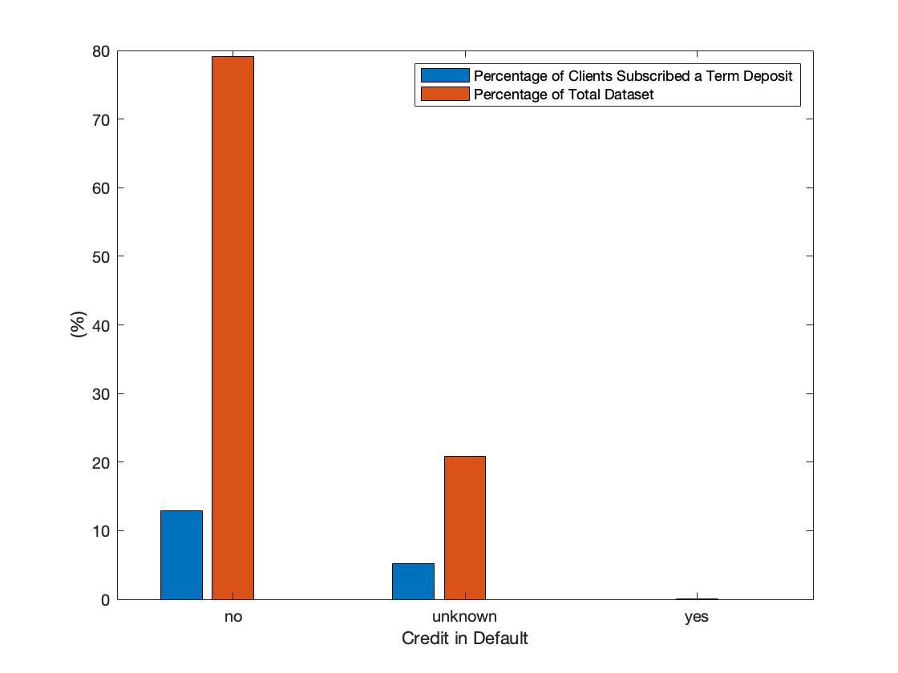

Figure 10: Analyze “Credit” Feature

In Fig. 10, it is clear that clients with no credit are more probable to subscribe a term deposit.

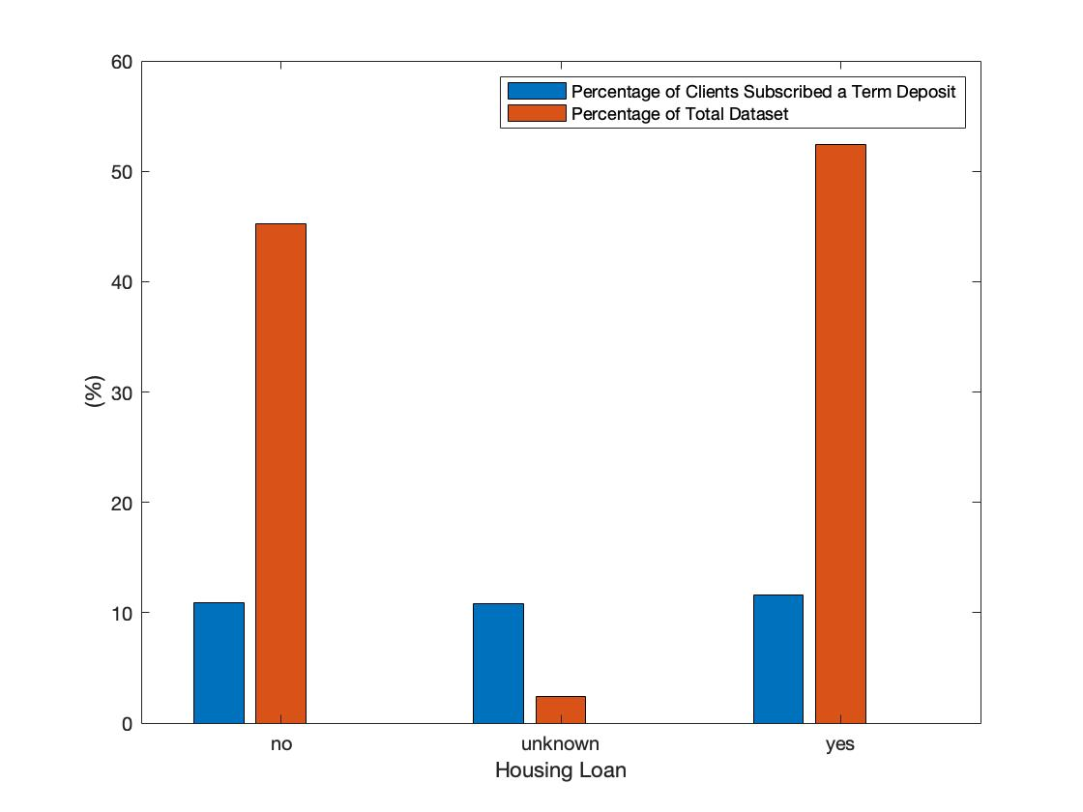

Figure 11: Analyze “Housing Loan” Feature

As shown in Fig. 11, it is not possible to extract useful information from this feature as the probability of subscribing are the same for all groups. Hence, it could be removed from independent variables.

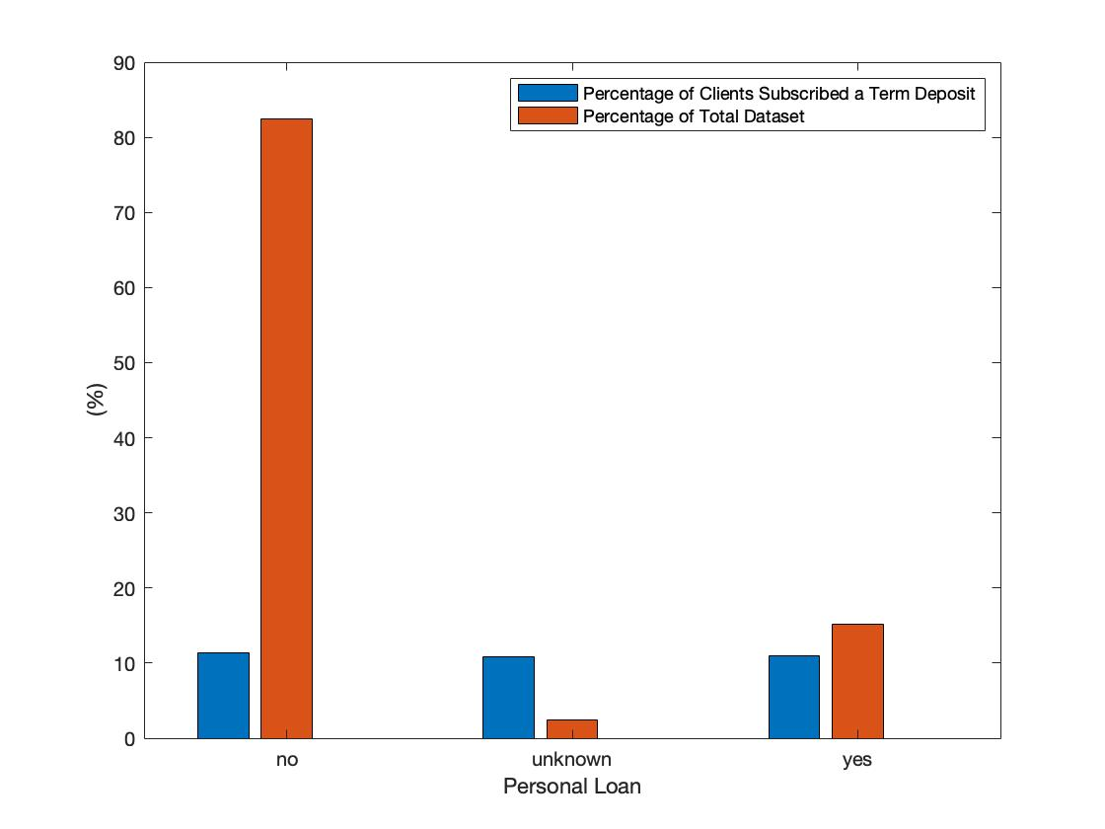

Figure 12: Analyze “Personal Loan” Feature

It Fig. 12, the dataset is balanced regards number of clients have housing loan or not. Therefore, useful information is less probable.

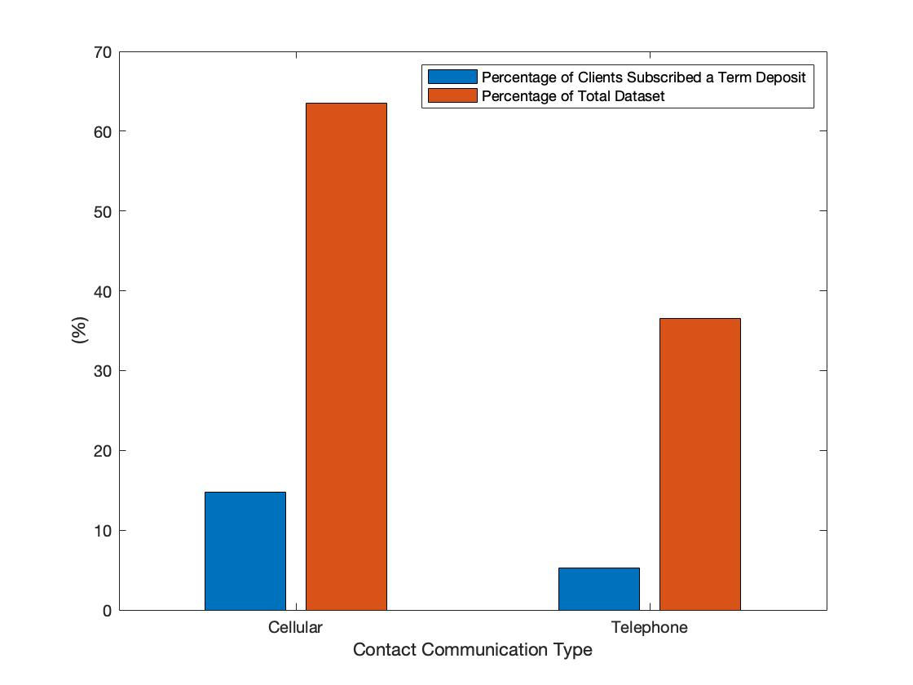

Figure 13: Analyze “Contact” Feature

Fig. 13 shows that using fixed-line network to talk with clients increases the risk of refusing to subscribe a term deposit by a client.

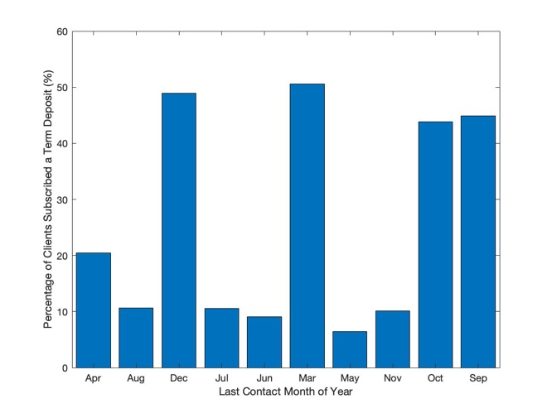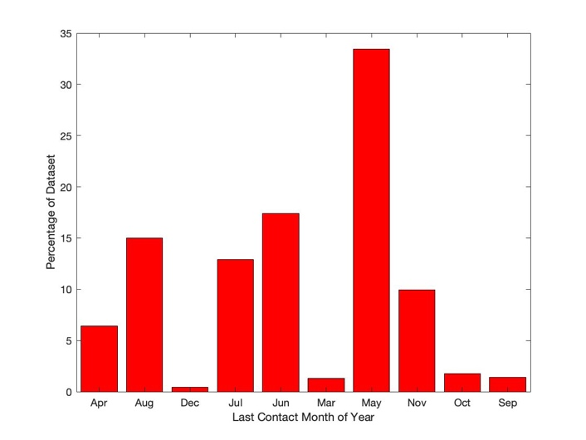

Figure 14: Analyze “Last Contact Month” Feature

In Fig. 14, the impact of contact month on subscribing a term deposit is visualized. Here, the probability of subscribing a term deposit is highly related to some specific months such as December and March.

Could be removed: It is worth mentioning that the feature “duration”, the duration of last time the bank has called to a client in seconds, is highly correlated with target variable because the more the bank talks with a client the more expected the client will subscribe to a term deposit because he/she shows higher interest. Therefore, to have a realistic model, it is better to ignore this feature.